**EXPERIMENT NUMBER –3.1**



**AIM OF THE EXPERIMENT –**Determination of value of Planck’s constant ‘h’.

# APPARATUS—

|  |  |  |  |
| --- | --- | --- | --- |
| S.No | Equipment | Range | Quantity |
| 1. | Digital voltmeter (DVM) | 0-20V | 1 |
| 2. | Digital milli ammeter | 30mA | 1 |
| 3. | Rheostat | 0-1000ohm | 1 |
| 4. | Resistor | 1K | 1 |
| 5. | LED’s | Different colors | 1 |
| 6 | Power Supply | 0-10V | 1 |
| 7. | A one way Key | NA | 1 |

**CALCULATIONS**-



E=hv……….(1)

E=Ev……….(2)

Where e=1.6 x 10^-19 C

We then solve equation (1) for h and replace the E term with the equivalent of E in equation (2), as well as replace υ with:

V=C/λ

Where c=3 x 10^8m/sec

We then get:

H=eV λ/c…………(3)

this equation can be rewritten as

V=hc/e λ  (4)

It is this equation that we will use to determine Planck's constant.

Where h is Planck’s Constant

ʋ is the frequency of light

# Diagram

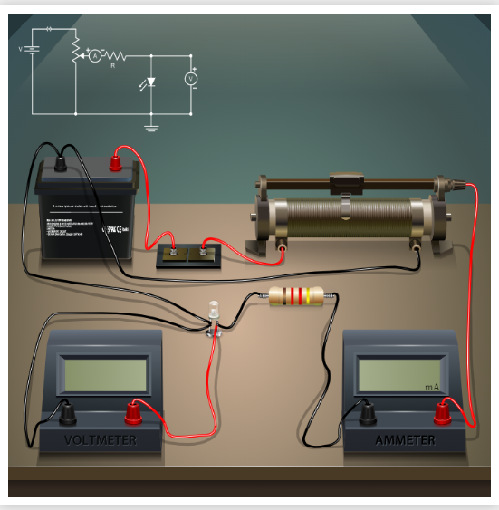

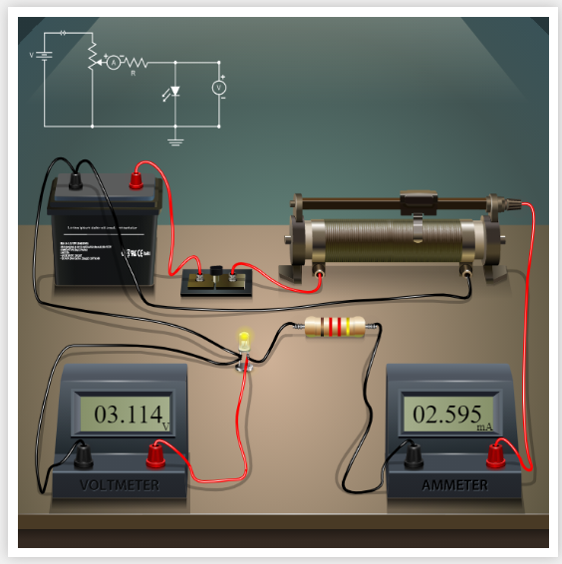

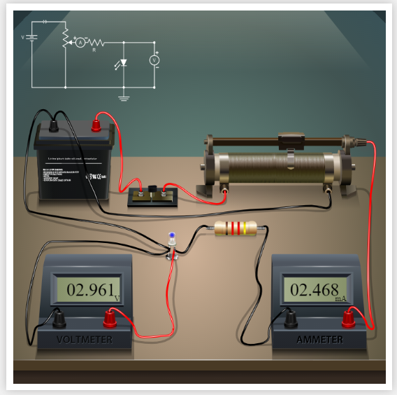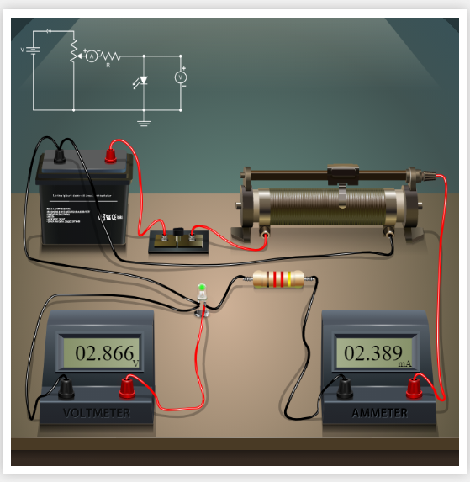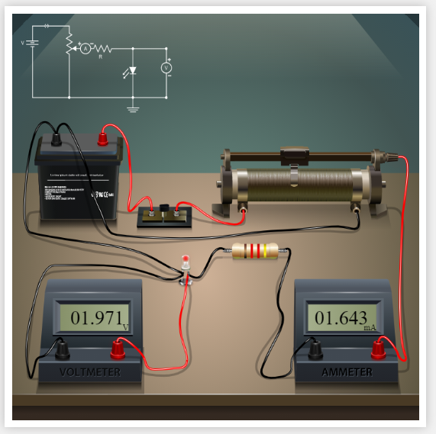

**OBSERVATIONS**:-

|  |  |  |  |  |  |  |  |
| --- | --- | --- | --- | --- | --- | --- | --- |
| **S.No** | **LED colour** | **Wavelength h λ (nm)** | **1/ λ** | **Stoppage voltage (v)** | **Energy (j) E=eV** | **Frequency V=c/ λ (10^14)** | **h=eV λ /c (J s)** |
| **1.** | Red | 650 | 1.538 x 10-6 | 1.908 | 3.0528x10-19 | 4.61Hz | 6.622x10-34 |
| **2.** | Green | 510 | 1.96 x 10-6 | 2.434 | 3.8944x10-19 | 5.88Hz | 6.624x10-34 |
| **3.** | Yellow | 570 | 1.754 x 10-6 | 2.178 | 3.4848x10-19 | 5.26Hz | 6.625x10-34 |
| **4.** | Blue | 475 | 2.105 x 10-6 | 2.615 | 4.184x10-19 | 6.31Hz | 6.630x10-34 |

# PERCENTAGE ERROR- N/A

**Graph—**

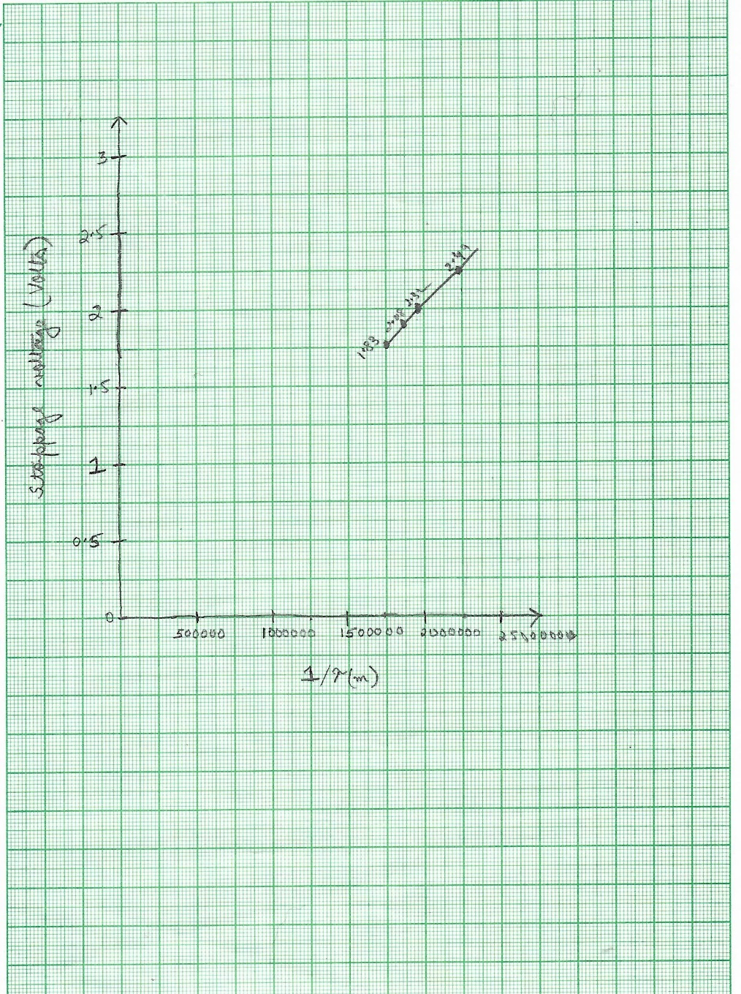

**RESULTS AND DISCUSSION**- The value of Planck’s constant ‘h’=   6.568×10-34  Js. The significance of Planck’s constant is that ‘quanta’ (small packets of energy) can be determined by frequency of radiation and Planck’s constant. It describes the behaviour of particle and waves at atomic level as well as the particle nature of light.  Our experimental value of Planck’s constant was well within the limits set by experimental uncertainty.

**LEARNING OUTCOMES**

* + It will provide the modest experience that allows students to develop and improve their experimental skills and develop ability to analyze data.
  + Ability to demonstrate the practical skill on measurements and instrumentation techniques of some Physics experiments. Students will develop the ability to use appropriate physical concepts to obtain quantitative solutions to problems in physics.
  + Students will demonstrate basic experimental skills by setting up laboratory equipment safely and efficiently, plan and carry out experimental procedures, and report verbally and in written language the results of the experiment.
  + Students will develop skills by the practice of setting up and conducting an experiment with due regard stom in imizing measurement error.

**EVALUATION COLUMN (To be filled by concerned faculty only)**



|  |  |  |  |
| --- | --- | --- | --- |
| **Sr. No.** | **Parameters** | **Maximum Marks** | **Marks Obtained** |
| 1. | Worksheet completion including writing learning objectives/Outcomes. (To be submitted at the end of the day) | 10 |  |
| 2. | Post Lab Quiz Result. | 5 |  |
| 3. | Student Engagement in Simulation/Demonstration/Performance and  Controls/Pre-Lab Questions. | 5 |  |
| 4. | Total Marks | 20 |  |
| 5. | Teacher’s Signature (with date) |  | |